Extra events………..

We will be taking part in Children in Need this year. We have various merchandise for sale in the main office we will also be wearing SPOTs on Tuesday 14th November please bring a 50p donation

Family services………..

Play and Learn is every Tuesday 9.15am – 10.45am. We are celebrating autumn this month in play and learn by starting to explore conkers and leaves in paint, sand and rolling them down drain pipes. We will also be scrapping out pumpkins and drying the seeds out to make pictures.

Beech room………...

"We would like to welcome all of the new children who have started with us in Beech Room since September. Children are settling into the room well, making new friends and enjoying new experiences. We have enjoyed reading Monkey Puzzle this term and children have all become very familiar with the story."

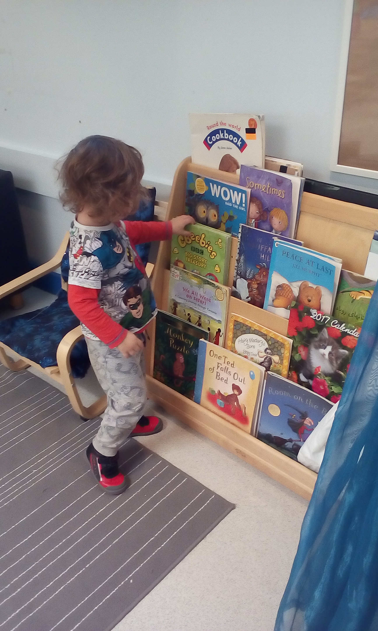 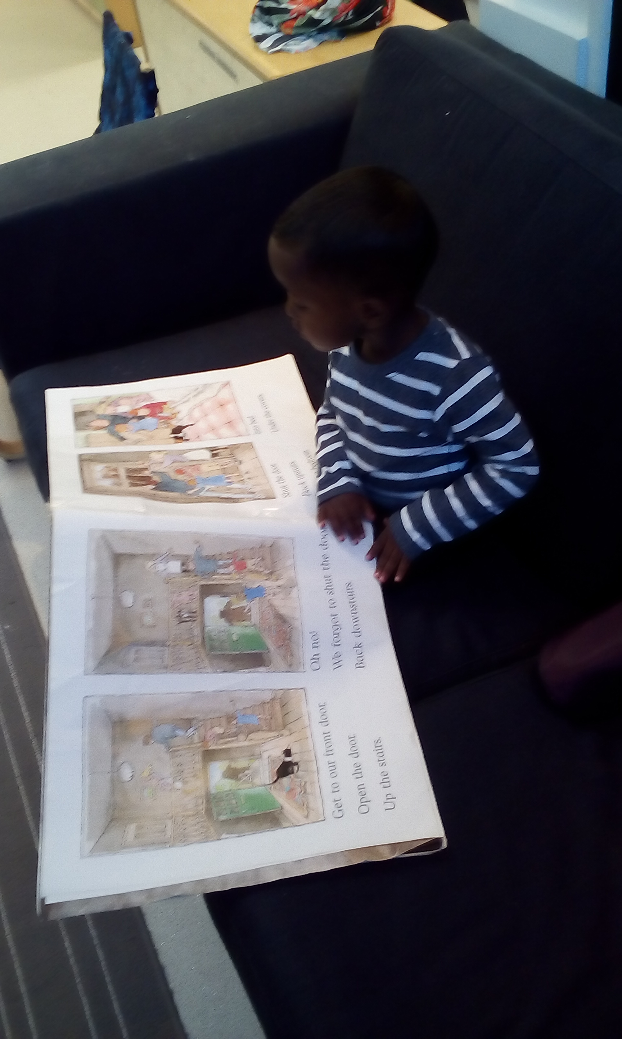

This term we have been collecting conkers on the Downs.

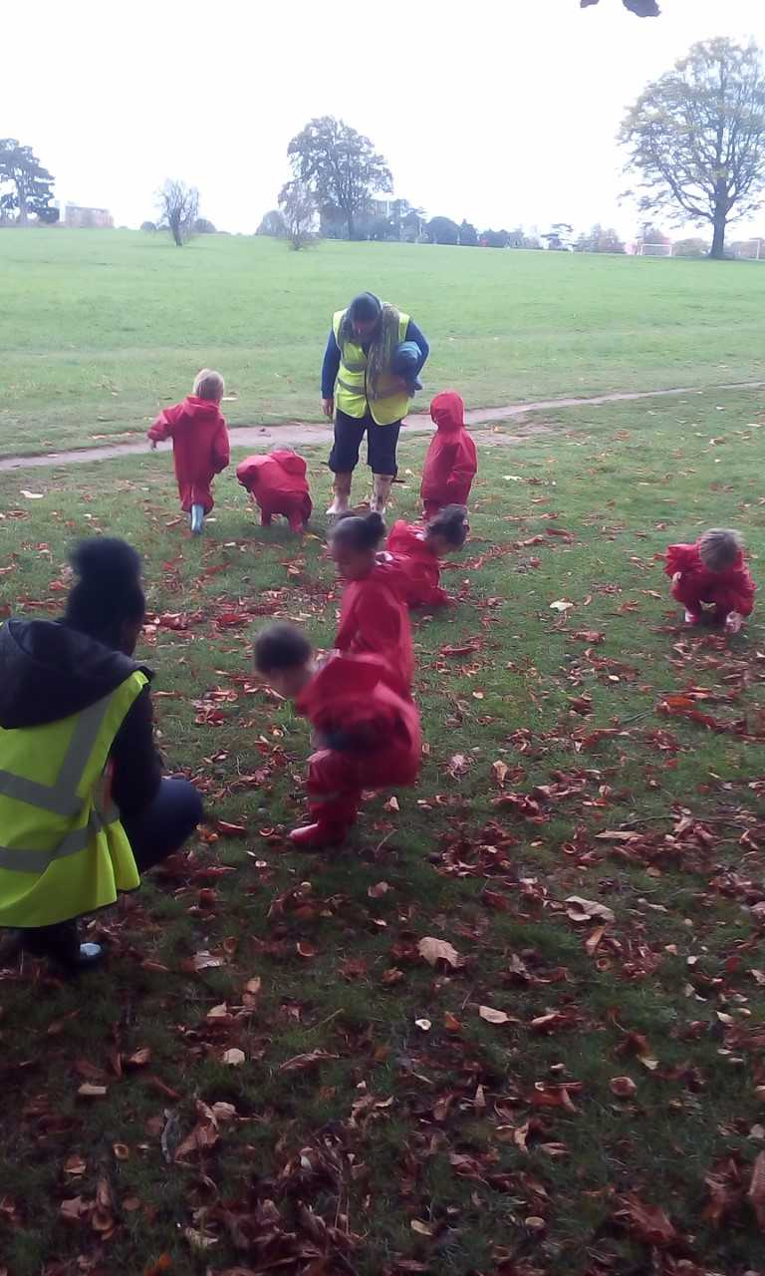 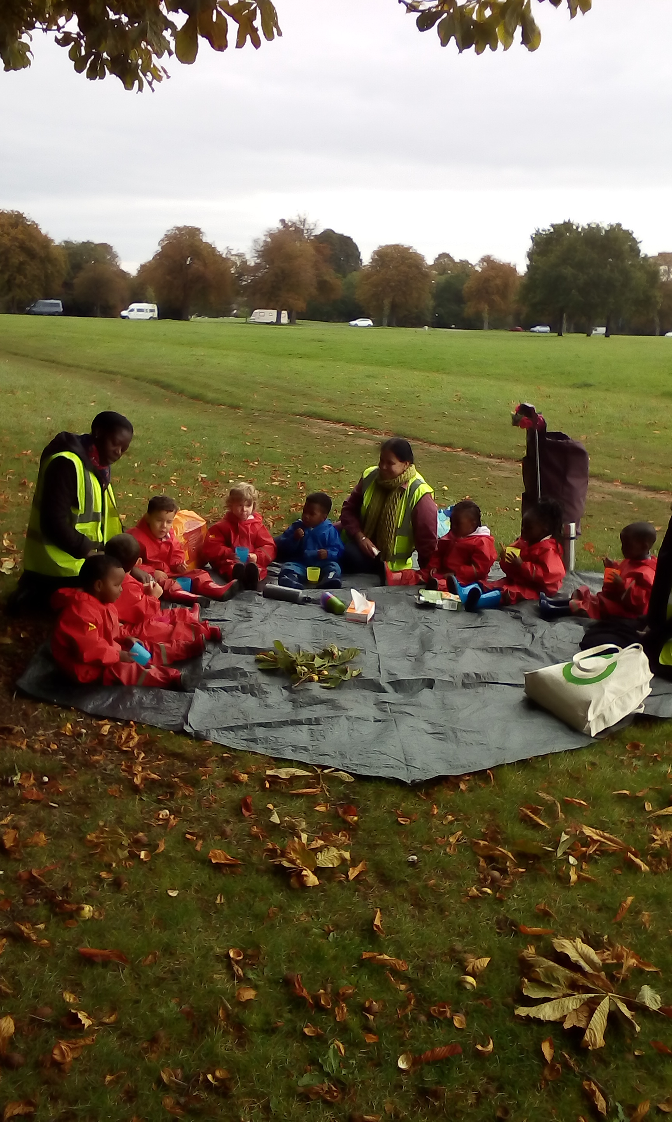

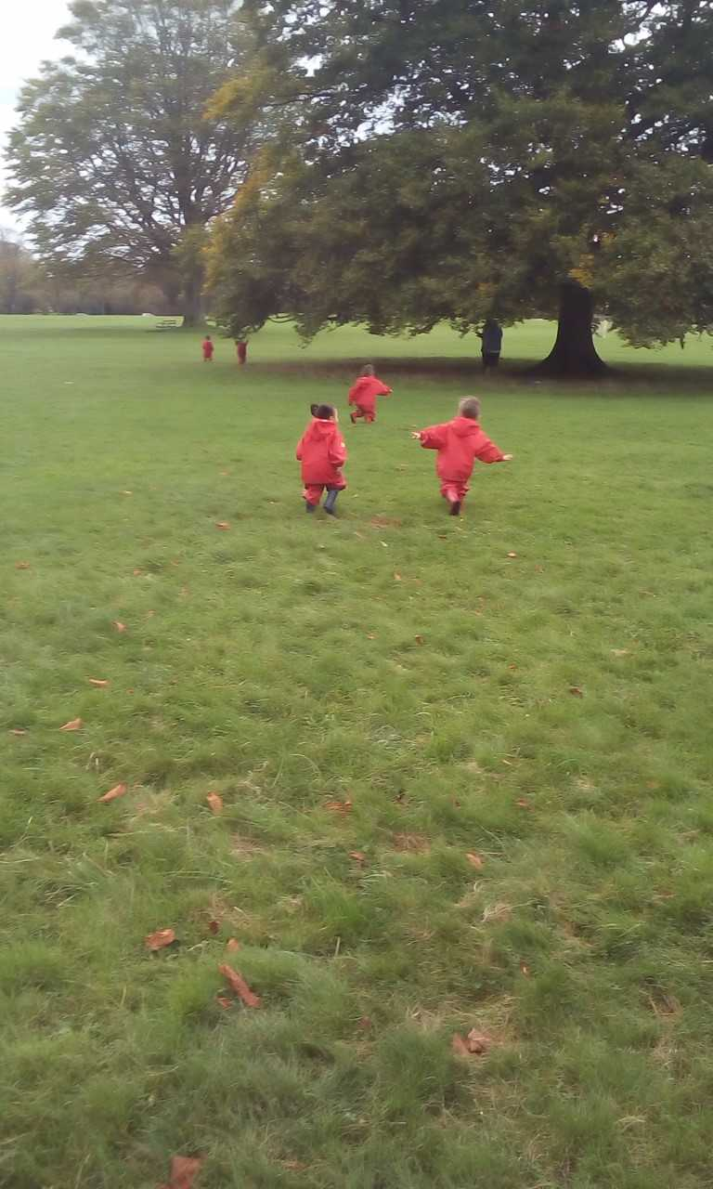

Home learning……….

**Children are like tiny flowers; they are varied and need care, but each is beautiful alone and glorious when seen in the community of peers.”** —Friedrich Froebel

Each key group has a mascot animal from the book ‘Brown Bear Brown Bear’ you can take a copy of the book and the key group mascot home with you and take photographs of your time together then this can be shared in the key group book. Ask your key worker for more information. Wendy’s Red group = red bird, Pauline’s Orange group = Orange fish, Juanita’s Green group = Green frog.

Some quick notes……

**Forest school**

This term we have been collecting conkers on the Downs. Clifton Down is just a short drive from Easton and there is plenty of space for freedom to run around. You can also get to the Downs by train from Stapleton Rd station to Clifton Down shopping centre. May be you might like to go and experience with your child? If you go, please tell us all about it and if you would like to join us for forest school trips please contact Anneke.

**Autumn celebration**

In Beech room children have been busy exploring conkers and dried leaves. We have been using them in painting, role play and construction activities. The children have been particularly keen to roll and race the conkers through the tubing in the constriction area. We have also been talking about Diwali, children have been using salt dough to create divas and listening to stories.

The change in weather has been of interest to the children, especially how much darker and windier it has been.

-------------------------------------------------------------**Workshops** Last year we ran some successful parent workshops, it covered subjects including water play, cooking and making puppets. We hope to do this again this year. If there is a particular area you would like a work shop on please inform a member of the Beech team. Keep an eye out for upcoming events.

-------------------------------------------------------------**Tapestry**  I hope you have been able to access your child’s Tapestry account without any issues, if you would like some help with this please see Kitty. We are keen to share your child’s learning and interests, please keep adding pictures and observations of your child’ learning from home so their keyworker can incorporate it into Beech room.

-------------------------------------------------------------**Invoices**

We would like to inform you that we are following a payment procedure policy and will be sending a standard letter out if a payment is missed.

However, if you have made a payment and receive a letter, please contact the office on 01179030269 and let the senior Administrator Nisha Khanna know when you made the payment. Can you also send confirmation of your payment to [schools.remittance@bristol.gov.uk](mailto:schools.remittance@bristol.gov.uk) so that the amount can be allocated to your account. Please put your full invoice number as reference.

Welcome to our termly newsletter. This will be produced every term and will keep you updated on events happening in the centre and activities that have been enjoyed. Any feedback as we develop this newsletter would be much appreciated.

Jenny Knight. Early Education lead

Term 1

September 2017

Beech room’s news

Important dates to remember…..

The centre is CLOSED for the Bank holidays and inset days

Monday 25th December 2017 (Bank Holiday)

Tuesday 26th December 2017 (Bank Holiday)

Monday 1st January 2018 (Bank Holiday)

Tuesday 2nd January 2018 (Inset Day)

Friday 30th March 2018 (Good Friday)

Monday 2nd April 2018 (Easter Monday)

Monday 7th May 2018 (Bank Holiday)

Monday 28th May 2018 (Bank Holiday)

Friday 29th June 2018 (Inset Day)

Monday 6th August 2018 (Bank Holiday)

Monday 27th August 2018 (Bank Holiday)

Tuesday 28th August to Friday 31st August 2018 (Inset Days)

TERM TIME ONLY

Finish on Friday 15th December 2017

The whole centre is closed

Wednesday 27th December 2017

Thursday 28th December 2017

Friday 29th December 2017

Announcements………..

Safiya Salaad had a baby boy on 1st Oct 2017. Both mum and baby are doing well.

Welcome back to Kay Jones, Beech room’s Team Leader Monday and Tuesday. Kay has been on maternity leave for the last year, we are looking forward to having Kay back to share some exciting play activity ideas with us!

Thank you Wendy McKelvey who has been covering the Team Leader post in Kay’s absence. Wendy has been a great support to the team and implemented some great home learning strategies that I am sure you will become involved in. Wendy is continuing her role as Key worker in Beech room.